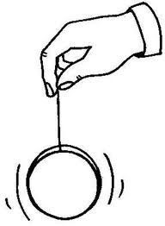
The Yo-Yo
Brendan walked downstairs one Saturday morning. His sister Emma was in the kitchen. She was playing with a yo-yo. Brendan frowned. It was his yo-yo! “Hey, that’s mine!” Brendan yelled. “Give it back!”
“But you weren’t using it,” Emma said. “That doesn’t matter,” Brendan said. “It’s mine. Give it back, now.” Emma almost looked like she was going to cry. But she didn’t. She gave the yo-yo to Brendan.
“It doesn’t matter,” she said. “I’m going to Holly’s party anyway. I don’t need your yo-yo.” Emma stomped off. Brendan played with the yo-yo a little bit. Then he got bored. He stuck it in his pocket.
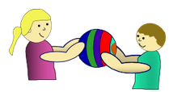
Emma went to her friend’s party. She came back two hours later. She looked really happy. She was tossing a small ball in the air. The ball made a noise when she threw it. “Holly gave them out at her party,” she said. “Cool!” Brendan said. “Can I try it?” Emma thought for a minute. “Okay,” she said. She gave Brendan the ball.
Brendan threw the ball in the air a few times. Then he started to feel bad. Emma could have kept the ball to herself. She could have gotten back at Brendan for not sharing his yo-yo. But she didn’t. Brendan reached into his pocket. “Hey, do you want to play with my yo-yo?” he asked. Emma smiled and said, “Thanks, Brendan.”

