* + [](http://images.google.com/imgres?q=foolish+clown&start=82&hl=en&tbo=d&biw=1280&bih=706&addh=36&tbm=isch&tbnid=d_d8hKAm8EZaEM:&imgrefurl=http://www.theamateurfinancier.com/blog/carnival-of-twenty-something-finances-evil-clown-edition/&docid=jDSQghMNZYtrMM&imgurl=http://www.theamateurfinancier.com/blog/wp-content/uploads/2009/11/Krusty-the-Clown.jpg&w=407&h=500&ei=knF0UOu2FMXJqQHIxoGgBQ&zoom=1)

Foolish

[[](http://images.google.com/imgres?q=frowns&hl=en&tbo=d&biw=1280&bih=706&tbm=isch&tbnid=Y4mLBOaSS7BErM:&imgrefurl=http://www.theallareequal.com/2012/04/quote-cute-frown.html&docid=1ZTMYfglNFjUiM&imgurl=http://2.bp.blogspot.com/-6GhG6cbCJFk/T5u9SYZKchI/AAAAAAAACbc/hYcBxb1Z4K4/s1600/frown.jpg&w=640&h=508&ei=OHJ0UPCOFMbqrQHF94DIBg&zoom=1)](http://images.google.com/imgres?q=frowns&hl=en&tbo=d&biw=1280&bih=706&tbm=isch&tbnid=Y4mLBOaSS7BErM:&imgrefurl=http://www.theallareequal.com/2012/04/quote-cute-frown.html&docid=1ZTMYfglNFjUiM&imgurl=http://2.bp.blogspot.com/-6GhG6cbCJFk/T5u9SYZKchI/AAAAAAAACbc/hYcBxb1Z4K4/s1600/frown.jpg&w=640&h=508&ei=OHJ0UPCOFMbqrQHF94DIBg&zoom=1)

Frown

[](http://images.google.com/imgres?q=ruffled&hl=en&tbo=d&biw=1280&bih=706&tbm=isch&tbnid=0COJSwJax0addM:&imgrefurl=http://tatertotsandjello.com/2011/02/great-ideas-ruffles.html&docid=rLrO4oMzm_h7kM&imgurl=http://tatertotsandjello.com/wp-content/uploads/2011/10/Ruffled+Pillow%5b4%5d.jpg&w=531&h=480&ei=OnN0UPOtO8OYqAGu7ICQAw&zoom=1)

Ruffled

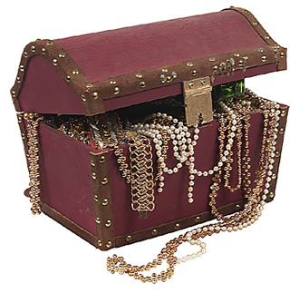  
Treasures

[](http://www.superhdwallpaper.com/wp-content/uploads/2012/10/tropical-beach-beautiful-wallpaper.jpg)

Tropical

* + [](http://images.google.com/imgres?q=special&hl=en&tbo=d&biw=1280&bih=706&tbm=isch&tbnid=LV5_ub2PbfyDlM:&imgrefurl=http://www.commentslive.com/comments/special.php&docid=89icr2kzdjpxfM&imgurl=http://www.commentslive.com/comments/cat/special/your-special.gif&w=500&h=500&ei=aHV0ULWeKurGygGu3YGgBw&zoom=1)

Special