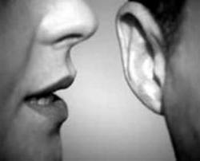

whisper

[](http://images.google.com/imgres?q=whistling&start=104&hl=en&tbo=d&biw=1280&bih=706&addh=36&tbm=isch&tbnid=xdGJ0CCpyMOlaM:&imgrefurl=http://www.clker.com/clipart-14510.html&docid=lQzj96023AwGwM&imgurl=http://www.clker.com/cliparts/1/4/a/0/11971038831932190305kelan_whistle.svg.hi.png&w=600&h=376&ei=3l1rULvQMeKLywGS1IHgAw&zoom=1&iact=hc&vpx=953&vpy=185&dur=1208&hovh=178&hovw=284&tx=173&ty=79&sig=103891225351094399275&page=5&tbnh=132&tbnw=211&ndsp=26&ved=1t:429,r:6,s:104,i:107)

[](http://images.google.com/imgres?q=whistling&start=233&hl=en&tbo=d&biw=1280&bih=706&addh=36&tbm=isch&tbnid=JYs7Bf2q_ywdCM:&imgrefurl=http://www.colourbox.com/image/sports-coacher-whistling-and-pointing-up-on-a-white-background-image-2345518&docid=MykBKqfxPLioSM&imgurl=http://www.colourbox.com/preview/2345518-219950-sports-coacher-whistling-and-pointing-up-on-a-white-background.jpg&w=480&h=336&ei=YV5rUMK9GYPVyQH-tIH4Cg&zoom=1&iact=hc&vpx=162&vpy=139&dur=508&hovh=188&hovw=268&tx=170&ty=106&sig=103891225351094399275&page=10&tbnh=156&tbnw=213&ndsp=24&ved=1t:429,r:7,s:233,i:191)

Whistle

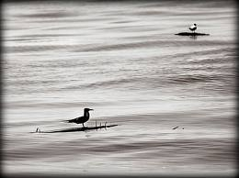

Drift

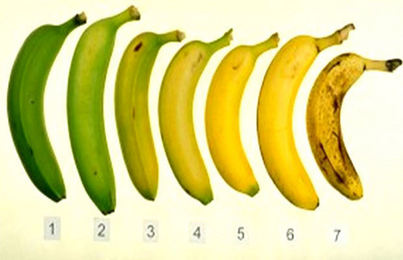

Ripen

[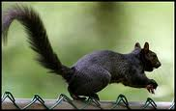](http://images.google.com/imgres?q=scurry+of+squirrels&start=97&hl=en&tbo=d&biw=1280&bih=706&tbm=isch&tbnid=fYMuDj--cvofyM:&imgrefurl=http://sandydgreen.wordpress.com/2010/09/28/a-scurry-of-squirrels/&docid=NTlG4ubOqCk8PM&itg=1&imgurl=http://sandydgreen.files.wordpress.com/2010/09/black-squirrel.jpg&w=228&h=144&ei=o1prUIzxA4LrygGL9oDYAg&zoom=1)

Scurry

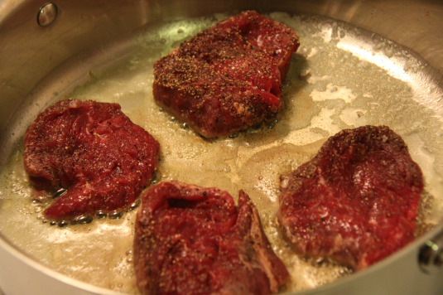

sizzle