

boring

[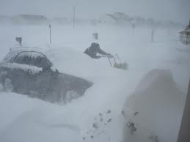](http://images.google.com/imgres?q=blizzards&hl=en&tbo=d&biw=784&bih=530&tbm=isch&tbnid=TO_42R2tvu0WdM:&imgrefurl=http://gph171ibarra.blogspot.com/2010/09/blizzards.html&docid=OWJmwZXBS1-APM&imgurl=http://4.bp.blogspot.com/_5Z_6lKh77iE/TIf7VDsKz0I/AAAAAAAAABw/5U1XTbVtxus/s1600/blizz2.jpg&w=1024&h=768&ei=TrgSUZqSF8qOygHz5IGgAQ&zoom=1&ved=1t:3588,r:18,s:0,i:201&iact=rc&dur=471&sig=101799873872668631593&page=3&tbnh=177&tbnw=250&start=16&ndsp=9&tx=72&ty=92)

blizzard

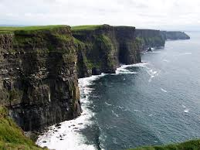

cliffs

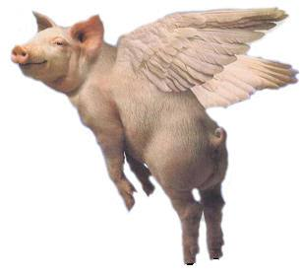

impossible

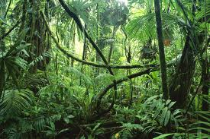

jungle

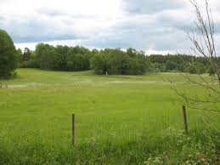

meadow