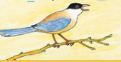  BIRD | BIRD | BIRD
DRUM | DRUM | DRUM
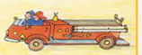  FIRE TRUCK | FIRE TRUCK | FIRE TRUCK
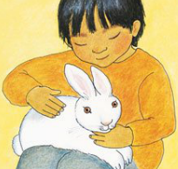  BUNNY | BUNNY | BUNNY
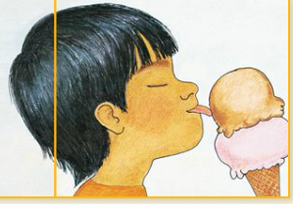  ICE CREAM | ICE CREAM | ICE CREAM
COOKIE | COOKIES | COOKIES
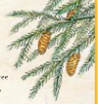  PINE TREE | PINE TREE | PINE TREE
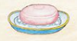  SOAP | SOAP | SOAP
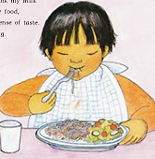  FOOD | FOOD | FOOD
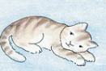  KITTEN | KITTEN | KITTEN
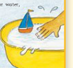  WATER | WATER | WATER

