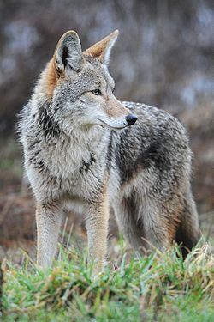
TEXT #1
Coyotes appear in many Native American tales. They are usually depicted as smart and strong beasts in stories. Coyotes are members of the dog family. They once lived in open prairies and deserts, but they now roam the continent’s forests and mountains. These animals will eat almost anything. They hunt animals such as rabbits, fish, frogs, and even deer. They can also eat insects, snakes, fruit and grass. They are known for killing pets such as cats and small dogs. People who live in the desert must be careful of leaving small animals alone outside at night.
Coyotes live in prairies, deserts, forests, and mountains.
keep in touch with other coyotes.

TEXT #2
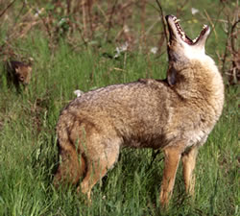
You will find coyotes in deserts and valleys. Desert coyotes are light gray or tan and have a black tip on their tail. Coyotes travel during the day and hunt at night. They can run swiftly which helps them catch their prey easily. Coyotes eat meat and fish. They don’t even mind eating spoiled and rotten meat. The coyote is one of the few animals whose howls are heard at night. Coyotes can howl, yelp, bark and huff. Their howls are used to keep in touch with other coyotes in the area. The coyote is a member of the dog family. The coyote even looks like a medium sized collie dog. One of the main differences is that the tail of the coyote is round and bushy.
Coyotes often howl at night. They howl to keep in touch with other coyotes.

