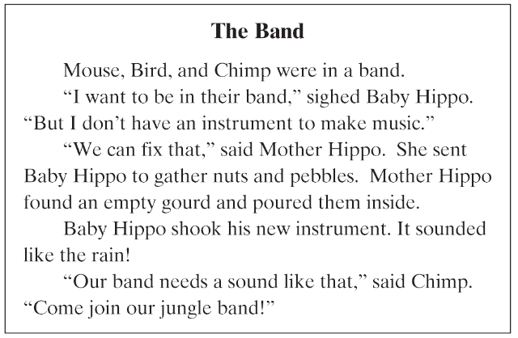

[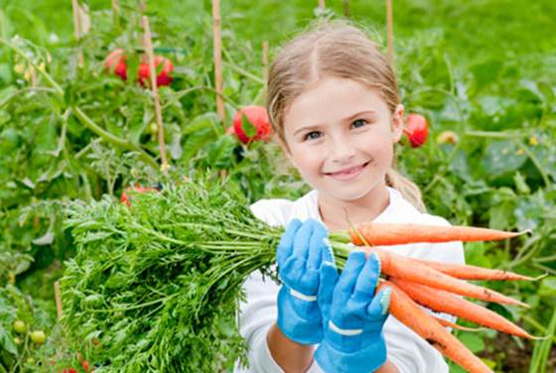](http://www.google.com/url?sa=i&rct=j&q=&esrc=s&frm=1&source=images&cd=&cad=rja&docid=TShUDFGvYSEoqM&tbnid=g6ny6IwhcGWMBM:&ved=0CAUQjRw&url=http://www.sheknows.com/parenting/articles/952457/spring-gardening-ideas-for-young-kids&ei=N_xfUs2dB-6GyQHhs4CABg&bvm=bv.54176721,d.aWc&psig=AFQjCNEoKuFdjbKsgmLJsimswYEyGQGY8A&ust=1382108586496374)Would you like to get your hands dirty at school? Some schools have their own gardens. The children decide what to grow. They learn how to plant seeds.

[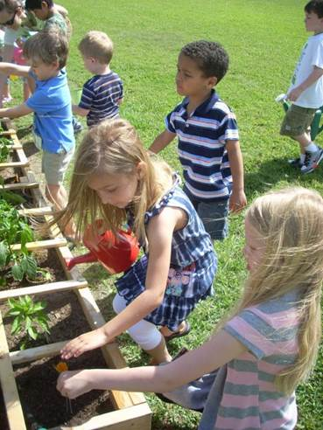](http://www.google.com/url?sa=i&rct=j&q=&esrc=s&frm=1&source=images&cd=&cad=rja&docid=lO7MDsB4_dVkTM&tbnid=0cBNm5fuiYGDNM:&ved=0CAUQjRw&url=http://blog.episcopalrelief.org/blog/episcopal-relief-and-development-stories/st-andrews-pearland-children-and-youth-grow-through-gardening&ei=Jv1fUrerA4TuyAHdvYDIAw&bvm=bv.54176721,d.aWc&psig=AFQjCNFlsQVyrfWdaOhihm8sUWtWzlvXBw&ust=1382108809583306) The children must water the plants and pull weeds in their gardens. They learn about good bugs and bad bugs, too.

*Children get to pick what they grew.*

Once the plants are grown, children get to pick what they grew. If they grew food, they can cook it and eat it.

School gardens are a good way to get fresh air and exercise. Children who plant gardens also enjoy eating the healthful foods that they grow. Gardening at schools can be healthy and fun, too!

Children must water the plants and pull weeds in their gardens.