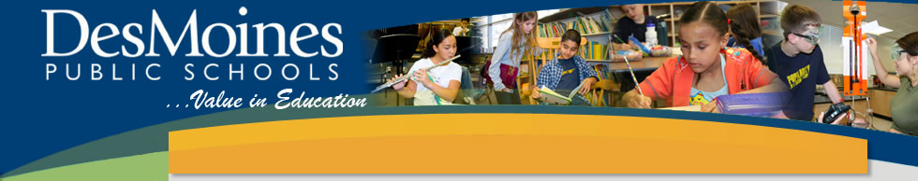
Elementary District PLC
April 16, 2014
2:30 – 3:45pm

Professional Development Objectives:
- Understand the basic elements of the Framework for Teaching Elementary Math with Go Math and discuss differentiation and small group instruction supports.
- Collaborate around your upcoming Science or Social Studies Unit by discussing ideas for teaching this content area.

What to Bring:
- 2013-2014 Teaching and Learning Documents
- Your DMPS Laptop

Agenda:
2:30pm Welcome, Reminders, and Logistics

2:35pm Framework for Teaching Elementary Math

3:15pm Social Studies/Science Collaboration

3:45pm Exit Slip & Dismissal

