Coral Reefs
Coral reefs are found in some oceans. These reefs are made of tiny animals. When these tiny animals die, they leave behind piles of empty shells. More tiny animals grow on top of these shells. This happens over and over again. The coral reef gets bigger and bigger.
You can dive near a coral reef! Everything you see will be beautiful. You might even see green sea turtles. They are a little bit scary, though. They are about three feet long and weigh about 300 pounds.
You may also see colorful angelfish. They aren’t afraid as they swim around. They can hide inside cracks in the coral if they need to be safe.
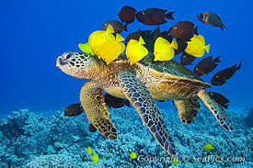
The fish are cleaning the sea turtle.

