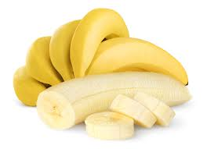Bananas
Bananas are a yellow fruit that grow in hot places. Sometimes it is called the “perfect fruit” because you don’t have to wash it and it is easy to carry. Bananas have smooth, yellow skin. Bananas are good for your body. For a good treat, add some banana slices to other foods like ice cream or a peanut butter sandwich. A banana is also a great breakfast food.

Pineapples 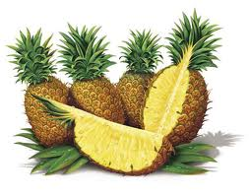
Pineapples are another kind of yellow fruit that grows in hot places. Pineapples are very juicy and sweet. They taste great when added to other foods, like pizza, ice cream, or cakes. Pineapples are also good for your body. Pineapples are not very easy to carry around because they are large and have bumpy skin. Since you don’t eat the skin of a pineapple, you don’t have to wash it before you eat it.

