Read the selection. Then read each question. Choose the best answer.

Being a Good Friend

1 Ellie hummed to herself as she waited for Jada at their usual meeting place, the oak tree by the traffic light. The two classmates had been best friends since they were introduced to each other in kindergarten. They met at that spot almost every day after school was dismissed, and then, laughing and chatting, they accompanied each other for the walk home.

2 Ellie’s apartment building was the first stop. The girls would arrive there, have some refreshments, and stay for a while to play and to visit.

3 As Ellie waited this afternoon, she scanned the lawn for four-leaf clovers that she could give to Jada, because Jada considered them a sign of good luck.

4 Ellie was concentrating so hard on her search that she didn’t notice Jada had passed by. When she looked up, she saw Jada walking with Katie, whose family had just moved there from out of state.

5 Ellie scrambled to her feet and reached for her knapsack. She called out to Jada, but her friend acted as if she had not heard. Ellie raced down the street until she caught up with Jada.

6 “Hey, did you forget about me?” Ellie asked.

7 Jada and Katie exchanged glances. Then Jada looked coolly at Ellie.

8 “I thought I saw you sitting there, but I wasn’t sure,” she said.

9 “Why didn’t you say anything?”

10 “You were so busy picking at the grass, I didn’t want to disturb you,” Jada said.

11 Her new friend giggled, and made no effort to hide her amusement. Ellie felt embarrassed and confused at the idea of Jada making fun of her. She turned away abruptly and walked to her house alone. After closing the door behind her, she peered out the window as the two girls walked together past her house.

12 The next day, Ellie wondered if Jada would call for her on her way to school. However, when she saw Jada approaching with her new friend, Ellie hid in the living room until they were out of sight. Later she trudged to school by herself, feeling more alone than she had ever felt in her life.

13 After the dismissal bell sounded, Ellie waited again by the oak tree. This time, she didn’t search for clovers. Instead, she pretended to be fascinated by her math textbook. When she heard giggling, she knew that Jada and her new friend were nearby. Again, Jada did not stop to give a greeting, so Ellie continued to read as if there were nothing else in the world except that textbook. Inside, however, she felt very sad.

14 As the days passed, Ellie no longer waited for Jada after school by the oak tree. Ellie missed her friend, but she didn’t know how to attract her attention, so she decided to just leave it alone.
15 One Friday, Ellie noticed Jada leaning up against the bark of the oak tree. She walked over and said hello. Jada smiled shyly.

16 “I’ve been such a bad friend,” said Jada regretfully. “I’m sorry.”

17 “It’s okay,” answered Ellie, though the expression on her face showed that it really wasn’t.

18 “It was interesting to meet Katie,” Jada went on. “We have a lot of the same interests, you know. But I know that was no excuse to treat you poorly. Now Katie has found a new friend, and I think I know just how you felt. Ellie, can you forgive me?”

19 When Ellie said yes this time, she meant it sincerely.

20 “I have something for you,” said Jada. She displayed a four-leaf clover, which she had carefully glued to a hand-painted cardboard rectangle. Plastic wrap protected the leaves.

21 “I found it yesterday in my front yard,” Jada went on. “I know it’s good luck, since you are still my friend!”

- This story first takes place—
- on a neighborhood street.
- in Ellie’s living room.
- at the bus stop.
- in Jada’s front yard.

- From which point of view is this passage narrated?
- First person point of view
- Second person point of view
- Third person point of view
- None of the above

- Which sentence below from the story BEST proves the point of view used in the passage?
  - “Hey, did you forget about me?” Ellie asked.
  - “You were so busy picking at the grass, I didn’t want to disturb you,” Jada said.
  - Ellie was concentrating so hard on her search that she didn’t notice Jada had passed by.
  - Plastic wrap protected the leaves.

- Jada refuses to answer when Ellie calls to her because she—
  - is too interested in her math textbook.
  - has been trying to hide from Ellie.
  - does not realize Ellie is there.
  - is with Katie and ignoring Ellie.

- Which event helps Jada realize how poorly she has treated Ellie?
  - Ellie’s family moves to another state.
  - Ellie tells her how hurt she is.
  - Katie treats Jada the same way.
  - Katie tells Jada she has been mean to Ellie.

- Which detail from the story shows the reader that Ellie is lonely?
  - Ellie’s apartment building was the first stop.
  - Ellie trudged to school by herself.
  - Ellie noticed Jada leaning up against the bark of the oak tree.
  - Ellie hid in the living room until they were out of sight.

- Which detail from the story supports the idea that Jada felt bad about how she treated Ellie?
  - She gave her a four-leaf clover.
  - She leaned against the oak tree.
  - She walked home with Katie.
  - She said she didn’t want to disturb Ellie.

- At the end of story Ellie and Jada remain friends. What can you conclude about Ellie?
  - She is jealous of Jada.
  - She is angry at Jada.
  - She is forgiving of Jada.
  - She is grateful of Jada.

- Based on the details from paragraph 7, I can infer Ellie is feeling—
  - angry.
  - surprised.
  - happy.
  - left out.
Read the selection. Then read each question. Choose the best answer.

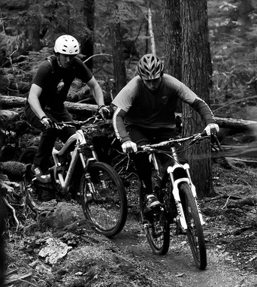
Good Health

1 What’s so great about exercise? Even if the thought of jogging around a track, jumping rope, or getting hot and dirty makes you shudder, there are ways that working out can still be fun. You might enjoy a game like volleyball, or maybe you ride your bicycle with friends. You could also get moving through the daily responsibility of walking your dog.

2 These are all ways to work out, or exercise. Exercise is a must in order to gain and preserve good health. It strengthens your body, gives you more energy, and even makes you feel happier.

3 When you exercise, you use your muscles. This makes them stronger, including muscles deep inside the body, such as your heart. The job of the heart muscle is to pump blood throughout the body. The blood contains oxygen, which reaches every part of the body by coursing through blood vessels. A strong heart gets the job done more effectively, and with less effort. It certainly is worthwhile to strengthen that muscle.

4 When you are healthy, you feel like you have more energy. Energy is the power to move around. A healthy body does not have to work as hard to move, and it does not get tired as quickly.

5 Another plus about exercise is that is makes you feel good. Exercise causes the body to produce a kind of chemical in the brain that calms you, and raises your spirits too. This chemical change is in addition to the good feelings you get from being stronger and having more energy.
6 Eating right is another way to stay healthy. Breakfast is very important if you make it a healthy one. It provides power to your body and to your brain.

7 It’s easier to choose healthy foods if you know what you need. Children generally need about a cup and a half of fruit and a cup and a half of vegetables every day. You should drink between four and eight glasses of water and juice each day.
8 The final ingredient for good health is to get enough rest. Growing children need an average of nine hours of sleep every night. When the body is asleep it repairs itself.

9 The body is like a machine. If you take good care of it, it can work well for a long time.

____

- Why does exercise make you feel good?
  - it builds stronger muscles including your heart muscle
  - it causes the body to produce a chemical in the brain that calms you and raises your spirits
  - it pumps blood that contains oxygen throughout the body which reaches every part
  - because you enjoy riding your bicycle with your friends on a dirt trail

- Sleep helps the body by—
  - giving it more oxygen.
  - allowing it to repair itself.
  - raising its spirits.
  - pumping blood through it.

- Why does the author say that the body is “like a machine”?
  - It is very powerful.
  - It works all the time.
  - To get it to work well, you must take good care of it.
  - It does what you need it to do automatically, with no effort from you.

- A healthy body is different from an unhealthy body because a healthy body—
  - never gets tired.
  - gets tired quickly.
  - has less energy.
  - has more energy.

- Identify the text structure demonstrated in this sentence from the passage:
When you are healthy, you feel like you have more energy. Energy is the power to move around. A healthy body does not have to work as hard to move, and it does not get tired as quickly.
  - sequence of events
  - cause and effect
  - compare and contrast
  - problem and solution

- Which example supports the inference that eating healthy is an important step to staying in good health?
  - Children need to sleep 9 hours a night.
  - Children need to eat fruits and vegetables.
  - When you exercise your muscles get stronger.
  - Children should eat 3 meals a day.

- The text says children need 9 hours of sleep a night for good health. What can you infer about a student who only gets 6 hours of sleep a night?
  - The student will be hungry and thirsty before lunch.
  - The student will have enough energy for the entire day.
  - The student’s body will be able to repair itself quickly.
  - The student will have difficulty focusing on school work.

- What can you infer from paragraph 6 about eating breakfast?
  - It doesn’t matter what you eat for breakfast, as long as you have breakfast.
  - Skipping breakfast will not make a difference in your daily activities.
  - If you eat a healthy breakfast you can skip lunch that day.
  - Eating a good breakfast gives you energy for the day.

Read the selection. Then read each question. Choose the best answer.

All About Robots
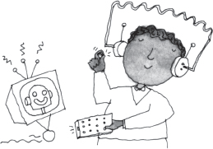
1 Did you know that you have robots in your home? Every time an alarm clock rings, you are hearing a robot. When your mother puts food in the microwave, she is using a robot. When you put a movie in to watch, you are using a robot. Robots have many uses.

2 What is a robot? A robot is a machine that can do work that is normally done by people. The robot is run by a computer, which acts as its “brain.” The brain tells the robot what to do.

3 Robots do many jobs that people do not want to do. They build cars, make parts for machines, and even make candy bars. Many companies use robots because they never get sick, they do not need to eat, and they never have to rest.

4 Some robots do jobs that are not safe for people to do. For example, the planet Mars would be a dangerous place to visit. So, scientists sent robots, instead of people, to check out Mars. The robots gathered important information about Mars. They then relayed that information back to Earth. This helps everyone to know more about the red planet.

5 Robots can go other places that would not be safe for people. They can go into burning buildings and help put out fires. Scientists use robots to go inside volcanoes and study what is happening. Robots can also be used to learn about the ocean, because they can dive far deeper than people. They gather information about fish and plants that people have never seen before.
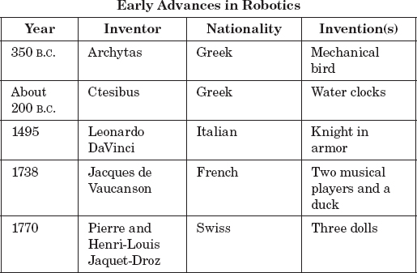
6 Soon robots may be used for even more important jobs. They could help police, doctors, farmers, and families. Yes, there may be even more robots in your home. Robots to help you clean the house and even to make you lemonade!

7 Look at the chart to learn about some of the early advances in robot history.

- According to information in the selection, what can you infer about the future of robots?
  - Inventors will learn from their mistakes.
  - Inventors will continue to make better robots.
  - Inventors will start learning more from the past.
  - Inventors will stop sending robots to places that are unsafe.

- Which column of the chart would the reader use to find out which inventor was Italian?
  - Year
  - Inventor
  - Nationality
  - Invention(s)

- According to the chart, Archytas and Ctesibus are alike because both—
  - made inventions in the same year.
  - have the same last name.
  - invented something musical.
  - shared the same nationality.

- What was the purpose of a chart, instead of a paragraph?
  - To make the selection look nicer.
  - To organize and compare large amounts of information.
  - To tell you what paragraph to find particular information.
  - Explains what is shown in a picture or illustration in the selection.

- Which detail supports the statement, “robots do jobs that are not safe for people” ?
  - They build cars.
  - They make candy bars.
  - They go inside volcanoes.
  - They clean your house.

- Which example supports the inference that scientists can count on robots because they are dependable?
  - They never get sick.
  - They need time to rest.
  - They need to eat.
  - They need constant maintenance.

