Read the selection. Then read each question. Choose the best answer.

Lost Pet

1 “Ziggy!” Jasmine stood on the porch and called her cat, but no orange-and-white tabby strolled out from behind the shrubs, or from under the minivan in the driveway.

2 Jasmine checked under her bed and under her computer table.

3 “Ziggy, where are you hiding?”

4 Searching inside the house had proved fruitless, so Jasmine returned to the yard, calling and calling her cat as she combed every hiding place she could remember. Ziggy had never been missing for so long before. Worried, Jasmine decided to ask her parents for help.

5 She found her mother in the den. “Mom, have you seen Ziggy?” she asked.

6 “Not since early this morning,” her mother replied.

7 Next, Jasmine asked her father the same question.

8 “I saw Ziggy strolling through the flowerbed, but that was hours ago,” he said.

9 By now, Jasmine was sure Ziggy had gotten lost. It was time to take action, so she took a sheet of paper, sketched a picture of Ziggy, and then wrote “Lost Cat” and her phone number below the drawing. She included a detailed description of her cat: large orange tabby, golden eyes, and fluffy coat of fur. Jasmine photocopied the posters and asked her mother to help her hang them up around the neighborhood. Then they went home to wait for a call.

10 Within two hours, she received a phone call in answer to her ad. A friendly voice on the other line said, “My name is Mrs. Garcia, and I believe I have Ziggy.”

11 Jasmine was so excited that she jumped up and down. Then she remembered to ask Mrs. Garcia for her address and phone number. Finally, she asked what had happened.

12 “A huge orange tabby just strolled into my yard this afternoon. He has been resting on the porch, and he looks very comfortable,” she added.

13 “I’ll be right over to see if it’s Ziggy,” Jasmine exclaimed. She and her parents climbed into their minivan and drove to Mrs. Garcia’s house.

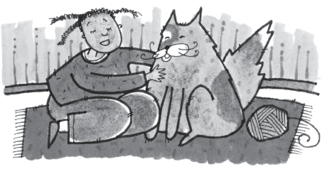
14 Once Jasmine and her parents got to Mrs. Garcia’s house, they discovered that the tabby was indeed Jasmine’s lost Ziggy. Jasmine immediately scooped him up in her arms, nuzzled him, and buried her face in the soft fur of his neck. Ziggy closed his eyes and purred, as if his wandering away and being found again had been the most natural thing in the world.
15 Jasmine slipped the cat into his carrier, snapped the latch shut, and slid the carrier into the minivan. Her parents thanked Mrs. Garcia for her help, and drove their daughter and her beloved pet back home.

16 The next afternoon, Jasmine spotted Mrs. Garcia walking down the street. Mrs. Garcia wore a worried expression on her face.

17 Jasmine waved to her and walked over. “Is something wrong?” she asked.

18 “Yes, Jasmine. It’s odd, coming so soon after your adventure with Ziggy, but today my dog, Diego, is missing.”

19 “Tell me about him,” Jasmine asked. Mrs. Garcia described Diego’s looks and personality.

20 “Is he a beagle?” Jasmine asked, and Mrs. Garcia nodded yes.

21 “I can help,” Jasmine said. “I’ll make posters for you and put them up.”

22 Jasmine went home and hurriedly sketched a picture of a beagle. She added Mrs. Garcia’s phone number, Diego’s name and description, and some details about how he got lost. Again she made photocopies, and again her mother helped her hang them up.

23 That evening, Mrs. Garcia called Jasmine with the happy report that someone had identified a lost beagle in his neighborhood as Diego.

24 “You used your experience with Ziggy to help me,” said Mrs. Garcia. “I really appreciate it. I’d like to invite you and your parents over tomorrow to meet Diego and to have some cookies,” she continued.

25 “I look forward to it,” Jasmine replied. “I’m so happy that both of our stories had happy endings!”

- Jasmine and Mrs. Garcia both—
  - have very large pets.
  - know how to draw animals.
  - lose their pets for a short time.
  - have a cat and a dog in their homes.

- Jasmine draws a picture of Ziggy—
  - to show how much she loves her cat.
  - to help people recognize Ziggy if they find him.
  - to encourage the neighbors to have cats as pets.
  - to give to her neighbor Mrs. Garcia.

- Mrs. Garcia finds Ziggy—
  - on her porch.
  - in her garden.
  - on the sidewalk.
  - in her neighborhood.

- What will Mrs. Garcia most likely do if Diego gets lost again?
  - wait for him to come home
  - call Jasmine to help her
  - check in her flowerbed
  - call the local pet shelter

- Showing compassion means helping others feel better. Which detail helps support this theme in the story?
  - Jasmine walked over to Mrs. Garcia when she looked worried.
  - Jasmine asked Mrs. Garcia if Diego was a beagle.
  - Jasmine took a piece of paper and sketched a picture of Ziggy.
  - Jasmine was so excited that she jumped up and down.

- The theme of this story is compassion, or being kind to one another. What detail does the author give to support this theme?
  - Jasmine checked under her bed and her computer table.
  - Jasmine slipped the cat into his carrier and snapped the latch shut.
  - Jasmine was so excited she jumped up and down.
  - Jasmine said, “I can help. I can make posters for you and put them up.”

- If you lose your pet, what detail from the story would prove that Jasmine is a good person to contact?
  - Jasmine is an excellent listener.
  - Jasmine is a wonderful artist.
  - Jasmine also has a pet.
  - Jasmine takes action.

Read the selection. Then read each question. Choose the best answer.

Recycling

1 Have you ever used an old bag or box? If so, you have recycled. One way to recycle is to reuse old things in new ways. For example, you can make a desk organizer out of an egg carton, use the Sunday comics to wrap a present, or jot notes on the back of an old envelope.

2 Many cities recycle. Residents put the trash that can be recycled into special bins. Glass, plastic, newspaper, some metals, and sometimes foam are among the materials that are recycled. The bins are put out with the trash, and picked up by sanitation workers. They are then sorted and taken to processing plants and factories to make new products. Therefore, recycling means less garbage.
3 What becomes of our recycled objects? Many new products are made from old ones. For example, old foam is shredded and pressed together into a jumble of many-colored foam, which is stuffed into pillows or used as carpet padding. Old paper turns up on store shelves as paper towels, cardboard, pet beds, and even as copier paper. Glass bottles and jars may be crushed into tiny pieces and used to pave roads, or they may be ground up into sand-size particles that are used on golf courses.

4 Recycled plastic has many uses. It is used to make toys, pens, pencils, fences, flowerpots, and outdoor furniture. Some kinds of plastic are even used to make soft, warm clothes!

5 It is important to recycle. It helps us to have less garbage. It also keeps us from wasting the Earth’s trees and metals. When we recycle, we are being smart and taking care of the Earth, ourselves, and our future.

6 Look at the graph to see how many tons of paper each city recycles in a year.

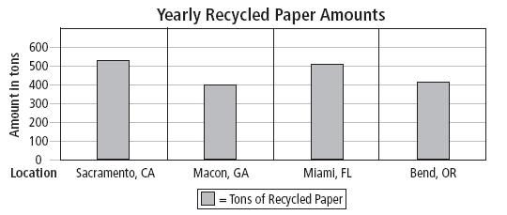

- Which reason best tells why the author wrote this article?
  - to inform readers about the benefits of recycling
  - to let readers know how to find a recycling center
  - to tell an entertaining story about recycling in one city
  - to convince readers to buy products made from garbage

- According to the selection, people at home can help reduce garbage by—
  - throwing out materials
  - grinding up glass
  - reusing materials
  - crushing up jars

- According to the selection, what will be the main problem if people choose not to recycle?
  - The earth’s trees and metals will be wasted.
  - No new products will be developed.
  - Cities will have to hire more sanitation workers.
  - Cities will have to distribute more recycle bins.

- Which sentence below supports the author’s point that recycling is important?
  - If you recycle you can earn extra money from the recycling center.
  - Garbage is stinky and messy.
  - When we recycle we are being smart about taking care of the earth.
  - Recycling foam makes pillows and carpet padding.

- According to the graph, the city that recycled the most paper was—
  - Bend, OR
  - Macon, GA
  - Miami, FL
  - Sacramento, CA

- Which sentence describes the main idea of this story?
  - Many cities recycle tons of paper yearly.
  - Recycled plastic has many uses such as toys, fences, and furniture.
  - Many new products are made from old products.
  - When we recycle we protect the Earth, ourselves, and our future.
Read the selection. Then read each question. Choose the best answer.

Gathering Food

1 From the moment Adahy caught a glimpse of the big orange sun appearing over the mountain tops, he was positive that today would be a great day. Adahy and his friends would gather acorns to store for the winter months, an important task because the acorns would nourish the people in the cave when food was scarce.

2 Adahy anticipated his friends emerging from the cave, and then the three of them would start searching for acorns. As Adahy stared at the giant oak and hickory trees that surrounded the cave, he contemplated the various tasks assigned to each person who lived in the cave. The men constructed tools for hunting and fishing, while the women crafted pots and gathered berries, roots, and seeds to eat during winter.

3 Finally, Tooantuh and Sheasequat appeared. Sheasequat glanced at Adahy’s empty hands and asked, “Adahy, do you have a pot to put the acorns in?”

4 “Oh, I forgot, but I will get it now,” said Adahy. He disappeared into the cave and quickly returned with two large clay pots.

5 Adahy, Tooantuh, and Sheasequat started out on the path into the forest. The lofty trees towered over the boys, forming a tunnel into the woods. The boys were cautious about staying together and on the path. They listened closely to the sounds of the forest, straining their ears to hear squirrels chattering, a telltale sign of nearby acorns.

6 “Stop!” Tooantuh whispered, holding out his hand. “I think I hear them.” The boys halted, looked up, and spotted several squirrels scampering among the trees.

7 “There they are,” Sheasequat said. “Now we are sure to find what we need.”
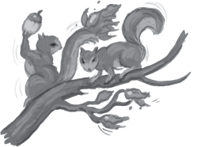
8 As squirrels scurried over their heads, Sheasequat, Tooantuh, and Adahy searched for acorns. They explored the forest around them and uncovered acorns under dried leaves and twigs. The squirrels found the acorns, too, in the oak branches above. Together the boys and the squirrels collected food for the winter; the squirrels would hoard them in their nests, while the people of the cave would store them in dirt holes to cool and preserve them.

9 When their pots were bursting with acorns, the boys returned to the path that would take them back to the cave. They would present the overflowing pots to Adsila, the food keeper, when they arrived.

10 “Adsila,” they called proudly as they entered the cave. “Look what we have found.”

11 Adsila turned to the boys and smiled. “You have done a great job. These acorns will feed many of us when it begins to snow. See what the women have collected for us.” She gestured toward the holes in the cave floor.

12 Adahy and his friends peered into one of the holes in the dirt and saw seeds, roots, and nuts. The boys’ pots of acorns made a significant contribution to the stores of winter food and would require a new hole. This winter, no one in the cave would go hungry.

13 Adahy was full of pride because he and his friends were helping to feed the cave families. He strolled out the cave entrance and gazed at the yellow sun setting behind the mountain tops against the rosy sky. Tomorrow would be an excellent day to forage for more food with Sheasequat and Tooantuh.

- Most of this story takes place—
  - near a stream.
  - in the woods.
  - in a hut.
  - in an oak tree.

- What problem does Adahy face as he prepares for his task?
  - He forgets his fishing tool.
  - He forgets his clay pots.
  - His friends disappear.
  - His friends do not help him.

- What is the best way to paraphrase the last sentence in paragraph 5?
  - The squirrel’s noises would lead them to acorns.
  - The squirrel’s noises would cause acorns to drop from the trees.
  - The squirrels would have already collected the acorns.
  - The squirrels would be so noisy that they would have to take another path.

- Which word best describes Adahy and the other members of the cave families?
  - Forgetful
  - Lazy
  - Over-confident
  - Hard-working

- Which sentence best describes the theme of the story?
  - Caring for the environment makes the world a better place.
  - Enjoying the simple things in life is important.
  - Walking in nature results in happiness.
  - Working together pays off in the end.

- Which of the following is the most complete summary of the passage?
  - Aday, Tooantuh, and Sheasequat watched the squirrels in the forest collect acorns for the winter.
  - Aday, Tooantuh, and Sheasquat went walking through the forest carrying heavy clay pots to collect seeds, roots, and nuts.
  - Aday, Tooantuh, and Sheasequat gathered acorns to supply food for the people in the cave for the winter.
  - Aday, Tooantuh, and Sheasequat forgot the pots needed to collect the food for the winter for the people in the cave.

Read the selection. Then read each question. Choose the best answer.

Fly High, Bessie Coleman
By Jane Sutcliffe

1 Two thousand people sat with their faces turned to the sky. High above the airfield, a pilot had just finished carving a crisp figure eight in the air. Suddenly, the plane seemed to stumble. Twisting and turning, it began to fall from the sky. The crowd watched in horror. Had something happened to the pilot?

2 But the woman in the cockpit of the plane on October 15, 1922, was in perfect control. Only two hundred feet above the ground she straightened out the tumbling aircraft and soared back into the sky. By the time she landed her plane, the crowd was on its feet, roaring with delight. Everyone cheered for Bessie Coleman, the first licensed black pilot in the world.

Growing Up
3 Bessie Coleman was born on January 26, 1892. She was a bright girl and a star pupil in school. In Waxahachie, Texas, where Bessie grew up, black children and white children attended different schools. Each year Bessie’s school closed for months at a time. Instead of studying, the children joined their parents picking cotton on big plantations. Bessie’s mother was proud of her daughter’s sharp mind. She didn’t want Bessie to spend her life picking cotton, and urged her to do something special with her life.

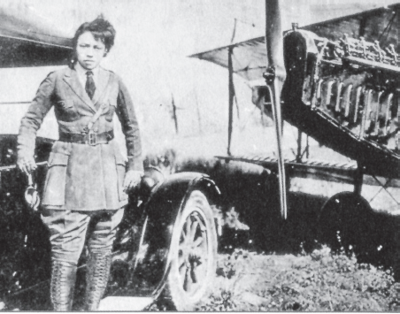
Learning to Fly
4 In 1915, when she was 23, Bessie Coleman moved to Chicago. She found a job as a manicurist in a men’s barbershop. Coleman loved her job and the interesting people she met there. After the United States entered World War I in 1917, soldiers returning from the war often came to the shop. Coleman was fascinated by their stories of daredevil pilots. She read everything she could about airplanes and flying. She later recalled, “All the articles I read finally convinced me I should be up there flying and not just reading about it.”

5 Bessie Coleman asked some of Chicago’s pilots for lessons. They refused. No one thought that an African American woman could learn to fly.
Coleman, in uniform, stands on the runner of a Model T Ford. The nose and right wing of her plane are to her left.

6 In desperation, Coleman asked Robert Abbott for help. Abbott owned Chicago’s African American newspaper, The Chicago Defender. He had often promised to help members of the black community with their problems. Abbott told Coleman to forget about learning to fly in the United States. Go to France, he said to her, where no one would care if her skin was black or white.

7 So she did. First Coleman learned to speak French. Then she applied to a French flying school and was accepted. On November 20, 1920, Coleman sailed for France, where she spent the next seven months taking flying lessons. She learned to fly straight and level, and to turn and bank the plane. She practiced making perfect landings. On a second trip to Europe, she spent months mastering rolls, loops, and spins. These were the tricks she would need if she planned to make her living as a performing pilot.

Performing in Airshows
8 Coleman returned to the United States in the summer of 1922. Wherever she performed, other African Americans wanted to know where they, too, could learn to fly. It was a question that made Coleman sad. She hoped that she could make enough money from her airshows to buy her own plane. Then she could open a school so everyone would have a chance to feel the freedom she felt in the sky.

9 By early 1923, Coleman was close to her goal. She had saved her money and bought a plane. Then, as she was flying to an airshow in California, her engine stalled. The brand-new plane crashed to the ground.
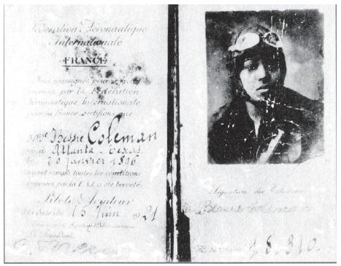
10 Coleman suffered a broken leg and three broken ribs. Still, she refused to quit. “Tell them all that as soon as I can walk I’m going to fly!” she wrote to friends and fans.

11 Many people, both black and white, were very impressed by Coleman’s determination. A white businessman helped her buy another plane. By 1926, Coleman was back where she had been before the crash. She wrote to her sister, “I am right on the threshold of opening a school.”
Bessie Coleman was awarded her pilot’s license in 1921.

12 In 1929, three years after her death, the Bessie Coleman Aero Clubs were formed. The clubs encouraged and trained African American pilots—just as Coleman had hoped to do. In 1931, the clubs sponsored the first All-African-American airshow. Bessie Coleman would have been proud.

- Which section of the selection best explains how Bessie finds flying lessons?
  - Growing Up
  - Learning to Fly
  - Performing in Air Shows
  - Fly High, Bessie Coleman

- Which of the following statements best describes why the author wrote this article?
  - to persuade others to attend airshows
  - to prove that France has the best pilot schools
  - to describe a person who followed her dream and made it come true
  - to explain that if you are different, it is difficult to get what you want

- Which sentence best describes how the selection is organized?
  - It tells the steps one must go through in order to become a famous pilot.
  - It explains problems in learning to fly and how the problems are solved.
  - It compares and contrasts flying with other daring performances.
  - It explains the important events of one person’s life in order.

- If Bessie had lived longer, she MOST LIKELY would have—
  - gone back to France to learn more about flying.
  - taught other African Americans how to fly.
  - stopped writing letters to her sister .
  - gone back to being a manicurist.

- What caused Bessie Coleman to go to France to attend flying school?
  - France had better airplanes.
  - In France, skin color didn’t matter.
  - Bessie was an adventurous woman.
  - Bessie Coleman could speak French.

- Which detail explains why Bessie’s plane crashed?
  - The engine stalled.
  - Bessie ran into bad weather.
  - The airplane ran out of gas.
  - Bessie was not an experienced pilot.

- Why does the author include captions with the photographs?
  - Captions help the reader say the words.
  - Captions help the reader determine unknown words.
  - Captions help the reader to understand a picture or a photograph.
  - Captions help the reader see what the person looks like.

