**Read the story. Then read each question. Choose the best answer.**

**Anna’s Adventure**

*1* Anna dressed in her new pants, tucked in her shirt, and brushed her hair. After she looked in the mirror and decided she was ready, she ran into the room where her parents were sitting.

*2* “You look so lovely,” her mother complimented her, smiling.

*3* “Thank you,” Anna said. “Can we leave now? I don’t want to be late.”

*4* “Are you excited about seeing your favorite writer?” her father asked.

*5* Anna grinned and nodded. Everyone knew how long she had been waiting for this day. She had read all the books written by Ms. Black and had even read some of them twice.

*6* Ms. Black was a well-known writer who wrote mostly mysteries. Although the books were like written puzzles, Anna could usually solve the mystery before the main character in the book did.

*7* Anna and her parents drove to the bookstore, and fortunately, there was little traffic. Anna was surprised but pleased that they had arrived early because they found seats close to the front. All the chairs were taken soon after they got there. The crowd was mostly young boys and girls, and everyone was discussing Ms. Black and their favorite books.

*8* The crowd became still when the owner of the bookstore walked out. He welcomed everyone warmly, and then mentioned there was a small problem. Anna wondered what the hold-up might be.

*9* “It seems Ms. Black is not here,” he told the crowd.

*10* Everyone seemed disappointed. Anna was perplexed at first, but then she remembered the plot of one of Ms. Black’s books. In the book, the main character was a writer, and the writer disappeared. Anna tried to remember what had happened in the book and began glancing around the room. A few other children seemed to understand that Ms. Black might not really be missing after all.

*11* Anna stood up and announced, “We have a mystery. Ms. Black is missing, so let’s figure out where she is.”

*12* The bookstore owner smiled, and the younger children in the crowd calmed down. Anna and the older children formed a group and began talking about where Ms. Black could be.

*13* “In Ms. Black’s book, what happened to the writer who disappeared?” Anna asked.

*14* One of the children replied, “The writer got lost in the library.”

*15* “Should we try to find her at the library?” another child asked.

*16* “I think maybe she’s here at the bookstore. Maybe she’s lost among the books here,” Anna suggested. “Let’s go look in the section where the mysteries are.”

*17* The children walked through the bookstore. Sure enough, sitting comfortably among the mysteries was Ms. Black, and she was reading a book. The children gathered around her in excitement. She told them what a good job they had done, and then she followed them into the room where everyone else was waiting. The crowd clapped when they saw her, and Ms. Black smiled proudly.

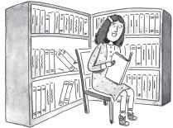

*18* “Thank you all for being here. I’m sorry I was late, but I suppose I got a little lost. Perhaps you could clap again for the children who solved tonight’s first mystery,” Ms. Black said.

*19* The crowd applauded again and then settled in to listen to Ms. Black read from her latest book.

1. What is the setting at the end of this story?

A. Anna’s house

B. a writer’s house

C. a bookstore

D. a library

2. At the end of paragraph 9, what question might good readers ask themselves to check their understanding?

1. Where is Ms. Black?
2. What is Ms. Black’s hair color?
3. What is Anna’s favorite type of book?
4. What story is Ms. Black reading?

3.What happens right after the bookstore owner says that Ms. Black is missing?

|  |  |
| --- | --- |
| A. | The crowd seems disappointed. |
| B. | The bookstore owner smiles. |
| C. | Anna and her parents leave. |
| D. | Anna decides she is ready. |

4. How does Anna help solve the mystery?

|  |  |
| --- | --- |
| A. | Anna asks the children to find Ms. Black. |
| B. | Anna remembers Ms. Black’s book about a missing writer. |
| C. | Anna tells the crowd to look for Ms. Black in the library. |
| D. | Anna helps to calm down the younger children. |

5.How does Anna feel about Mystery books?

1. Mystery books are informative.
2. Mystery books are exciting.
3. Mystery books are difficult.
4. Mystery books are humorous.

6.Ms. Black tells the children they did a good job because they –

|  |  |
| --- | --- |
| A. | were able to find her. |
| B. | read all of Ms. Black’s books. |
| C. | came to listen to her speak. |
| D. | helped calm down the young kids. |

7.Which of these summaries is the best way to recount the entire story?

1. Anna dressed in her new pants, tucked in her shirt and brushed her hair. Her mother told her she looked lovely.
2. Anna and her friends found Ms. Black in the Mystery section. Everyone clapped when they saw Ms. Black. The crowd applauded again and then settled in to listen to her read from her latest book.

C. Annawas excited to go to the bookstore to meet her favorite author, where they discovered Ms. Black was missing. Anna and the other children worked together to solve the mystery. They found her and she read her latest book.

D. Anna and her parents drove to the book store. They arrived early, all the seats were taken soon after they arrived. Everyone was discussing Ms. Black and their favorite books.

**Read the text. Then read each question. Choose the best answer.**

**Wonderful Bones**

*1* Do you know how many bones are located in your body? When you were a baby, you had about 330 bones, and now you have just over 200 bones. The number decreases because some bones join together as you grow. Your wonderful bones work together to protect you and support your body.

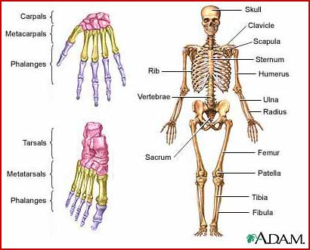

**Many Uses**

*2* Many bones protect your body. For example, the bone that makes up your head is called the skull. The skull surrounds your brain and protects it from harm. The ribs that cover your chest protect your heart and lungs.

*3* Other bones are used to support the body. The many bones in your feet allow you to walk and stand on your tiptoes. Finger bones move together so that you can throw a ball or tie a bow. Your hands and feet have more than half of the bones in your body! When you think of all that you do with your hands and feet, it’s a good thing they have so many bones.

**Biggest Bone**

*4* The longest and strongest bone in your body is in your leg. It is called the femur, and it goes from your hip to your knee. It is a very important bone because it carries all of your weight and helps you move from place to place.

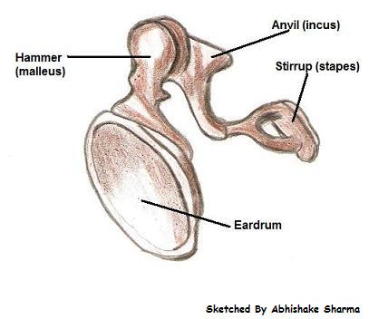**Smallest Bone**

**Diagram of Ear Bones**

*5* Would you believe the smallest bone in your body is in your ear? It is about the size of a grain of rice and is called the stirrup. It is called that because it is shaped like a tiny loop and looks like the stirrups on a saddle. When sound waves come into your ear, the stirrup shakes back and forth, allowing the sound waves to reach your brain. When the waves reach your brain, you hear the sound.

**“Funny” Bone**

*6* Hah! The funny bone isn’t really a bone at all. It is actually a nerve. When you hit the nerve that is near your elbow, it really hurts or tingles. What’s so funny about that? The funny bone probably got its name from the bone that is above your elbow. That bone is called the humerus, which sounds like the word “humorous,” meaning “funny.”

*7* The bones that make up our bodies are big, small, and in-between sized. They help us grow, protect us, and allow us to move. When you think about it, our bones really are wonderful.

8.What is the main idea of this text?

|  |  |
| --- | --- |
| A. | why we have fewer bones as adults |
| B. | how different bones help our bodies |
| C. | how the funny bone got its name |
| D. | why the longest bone helps us move |

9. How are the skull and ribs similar?

|  |  |
| --- | --- |
| A. | They both support the body. |
| B. | They both allow the body to move. |
| C. | They both are found in the chest. |
| D. | They both protect other body parts.  **____ 23.** |

10.How are the femur and the stirrup different?

|  |  |
| --- | --- |
| A. | The stirrup is bigger than the femur. |
| B. | The femur is a nerve and the stirrup is a bone. |
| C. | The femur is bigger than the stirrup. |
| D. | The stirrup is stronger than the femur. |

11.How did the funny bone probably get its name?

1. The bone above it hurts when you hit it.
2. The bone above it sounds like the word “humorous.”
3. The bone tells a knock-knock joke.
4. The bone above it has a funny shape.

12.Which text features help the reader understand the main idea of each paragraph?

1. title
2. chart
3. headings
4. conclusion

13.Under which heading does the author explain how bones help our bodies?

|  |  |
| --- | --- |
| A. | **Many Uses** |
| B. | **Biggest Bone** |
| C. | **Smallest Bone** |
| D. | **Funny Bone** |

14.Which parts of the body have the most bones?

1. ribs and arms
2. feet and hands
3. skulls and ears
4. ears and legs

15.Which sentence from the article states an opinion?

|  |  |
| --- | --- |
| A. | Finger bones move together so you can throw a ball or tie a bow. |
| B. | The longest and strongest bone in your body is in your leg. |
| C. | Would you believe that the smallest bone in your body is in your ear? |
| D. | When you think about it, our bones are really wonderful. |

16.What would happen if your stirrup was broken?

A. You couldn’t move your arm.

B. You couldn’t stand up.

C. You couldn’t carry your weight.

D. You couldn’t hear sound.

17.What would you **mostly likely** need if you broke your femur?

A. hearing aid

B. glasses

C. wheel chair

D. helmet

18.According to the author, our bones are so wonderful because—

|  |  |
| --- | --- |
| A. | they send sound waves. |
| B. | some make us laugh. |
| C. | some look like other things. |
| D. | they protect and support us. |

**Read the story. Then read each question. Choose the best answer.**

**Rainbow Trout’s Colors**

By Robert James Challenger

Illustrated by Susan Kwas

*1* Grandfather and his grandson were working outside, bringing in the winter firewood. The day was dull and rainy, and as they worked the cold water ran down their necks.

*2* The grandson said, “I wish it would never rain. I like the clear sky and the warm sun better.”

*3* Grandfather looked at him and said, “Let’s take a rest and I’ll tell you a story about the rain.”

*4* They found a dry spot under Cedar Tree to sit, and Grandfather began.

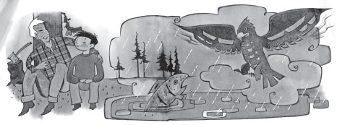

*5* *Down in the lake, Trout once felt the same way you do. He liked summer’s sun because food became more plentiful. This is when the water in the lake gets warm and the insects hatch.*

*6 One rainy day, Trout saw Eagle flying overhead and called out to him, “Eagle, can you fly up into the sky and drag the rain clouds away to the other side of the mountain?”*

*7 Eagle asked, “So you think it would be good for the rain to go away so you could have sun all the time?”*

*8 “Oh, yes,” said Trout. “It would be warm and bright and there would be lots of food for me.”*

*9 Eagle thought, “It looks like I need to teach Trout a lesson.”*

*10 Eagle flew up into the sky and dragged the grey rain clouds to the next valley, letting the bright sun shine down on Trout’s lake.*

*11 Trout was very happy. Every day was bright, warm, and cheerful, and there was a lot to eat. But after a while things started to change. Trout noticed that the water in the lake was not as deep as it used to be. The lake was getting smaller, leaving nothing but dry mud in its place. Trout also noticed that the insects, who needed the water to feed and hatch their eggs, had left. As the water got lower there was less to eat and Trout was finally trapped in a little pond with no food and barely enough room to turn around.*

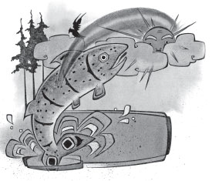*12 Trout looked up and saw Eagle watching him from a treetop. Trout called out, “Eagle, I was wrong. There can be too much sunshine. Now I know that rain is an important part of our world. Without it, the lake and everything I need to live will go away.”*

*13 Eagle flew over the mountain and dragged the clouds back. Just before they covered over the sun, a bright rainbow came down from the rain clouds and shone on Trout. The colors splashed onto his scales and changed him into Rainbow Trout.*

*14* Grandfather looked up into the sky and said to his grandson, “I accept the cloudy weather, just like Rainbow Trout now does, because I know that without rain there would never be rainbows. Remember, everything has a purpose, even though we may not always understand what it is.”

19. How is the story of Trout and Eagle similar to when Grandpa and his grandson are sitting and talking?

|  |  |
| --- | --- |
| A. | They were bringing in winter firewood. |
| B. | The character changed color. |
| C. | It rained that day. |
| D. | Both are in the mountains. |

20. How are Trout and Eagle different?

|  |  |
| --- | --- |
| A. | At first Trout did not understand what was good about rain, but Eagle did. |
| B. | Trout noticed all the things around him, but Eagle did not. |
| C. | Eagle was not bothered by the rain, but Trout knew he needed rain. |
| D. | Eagle did not have the power to stop the rain, but Trout did. |

21. What happens to Trout when there is no more rain?

|  |  |
| --- | --- |
| A. | Trout’s life gets easier because there is so much food. |
| B. | Trout enjoys the sunny days and never complains. |
| C. | Trout’s lake becomes dry, and there is no food. |
| D. | Trout decides to thank Eagle for taking the clouds away. |

22. Which word best describes Grandfather?

|  |  |
| --- | --- |
| A. | annoying |
| B. | wise |
| C. | hard-working |
| D. | careful |

23. What lesson does Eagle teach Trout?

|  |  |
| --- | --- |
| A. | It is best when everything is warm and bright. |
| B. | The sunshine brings food and warm water. |
| C. | The clouds can be taken to another place. |
| D. | Both sunshine and rain are necessary to live. |

24. What key details support the lesson Eagle teaches Trout?

|  |  |
| --- | --- |
| A. | Every day was bright warm and cheerful, there was lots to eat. |
| B. | Trout looked up and saw Eagle watching him from a treetop. |
| C. | The water in the lake was not as deep as it used to be. |
| D. | The colors splashed onto his scales and changed him into a Rainbow Trout. |
|  |  |

25. At the beginning, which of Trout's actions help the reader to know he is unhappy?

|  |  |
| --- | --- |
| A. | Trout saw Eagle watching him. |
| B. | Trout jumped out of the lake and yelled. |
| C. | The rain came down on Trout. |
| D. | Trout asked Eagle to drag the clouds away. |

26. How did Trout change from the beginning to the end?

|  |  |
| --- | --- |
| A. | Trout was annoyed at the beginning and accepted the rain at the end. |
| B. | Trout was joyful with the rain the whole time. |
| C. | Trout was selfish at the beginning and upset at the end because it was cloudy. |
| D. | Trout wanted to play with Eagle at the beginning and ignored him at the end. |