Read the story. Then read each question. Choose the best answer.
An African Folktale
Retold by Marilyn Helmer
Illustrated by Jose Masse

1 One day, a farmer decided to dig up some yams to sell at the marketplace. As he worked, he sang:

Sweet, sweet yam, so fine,

Sweet, sweet yam, all mine!

2 He had just pulled the first yam from the earth when it called out to him. “All yours? What are you talking about? Where were you when it was time to weed me and water me?”

3 The farmer was so scared that he jumped to his feet and raced off down the road. By the river, he passed a fisherman with a large fish in his net.

4 “Why are you running so hard on such a hot day?” asked the fisherman.

5 “My yam talked to me!” said the frightened farmer.

6 The fisherman rolled his eyes. “I’ve never heard of anything so ridiculous,” he said.

7 “I agree,” said the fish. “Everyone knows that yams can’t talk.”

8 The fisherman was so surprised that he threw the fish back into the river. Then he scrambled to his feet and ran on down the road, right on the farmer’s heels.

9 As the farmer and the fisherman rounded a bend, they came upon a girl carrying a large melon.

10 “Why are you running so fast on such a hot day?” asked the girl.

11 “My yam talked to me!” exclaimed the farmer.

12 “My fish spoke, too!” said the fisherman.

13 The girl laughed so hard she almost dropped her melon. “I’ve never heard of anything so ridiculous!” she said.

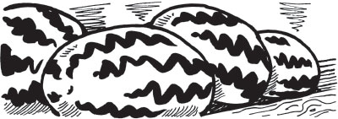
14 “I agree,” said the melon. “Everyone knows that yams can’t talk.”
15 The girl was so terrified that she actually did drop the melon. Then she ran away with the farmer and the fisherman as fast as her legs could carry her.

16 Up hill and down, they ran until they came to the king’s hut.

17 The farmer stopped to catch his breath. “We must tell the king what is going on,” he said.

18 “Yes,” said the fisherman, puffing and panting. “The king is a wise man.”

19 “He will know exactly what to do,” said the girl.

20 The three rushed into the king’s hut.

21 “My yam talked to me!” said the farmer.

22 The king gave the farmer a stern look. “Impossible,” he said. “You have been working too long in the hot sun.”

23 “My fish talked to me, too!” said the fisherman.

24 The king frowned. “Nonsense!” he exclaimed. “Your ears are playing tricks on you.”
25 “And my melon talked to me!” the girl finally added.

26 The king became very angry. “Foolish tales like that could frighten the entire village,” he roared. “Leave my hut immediately before I punish all of you severely!”

27 The farmer, the fisherman and the girl wasted no time in leaving the king’s hut. Foolish or not, they did not want to be punished.
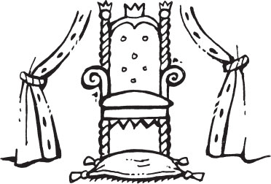
28 The king sat back in his royal chair. He shook his head. “Thank goodness they are gone,” he muttered to himself. “A talking yam indeed. I’ve never heard of anything so ridiculous.”

29 “I agree,” said his chair. “Everyone knows that yams can’t talk!”

1. In paragraph 6, which word best describes the fisherman when the farmer first tells him about the yam?

A. | scared
B. | annoyed
C. | sad
D. | glad

2. The farmer, fisherman, and girl are alike because they all…

A. | run when objects talk to them.
B. | think talking yams are funny.
C. | do not believe that yams talk.
D. | are nervous to see the king.

3. Which statement best describes how the king feels about the talking objects?

A. He is interested in the talking objects.
B. He is angered by the talking objects.
C. He is excited about the talking objects.
D. He is scared of the talking objects.
4. What happens at the end story?

A. | The fisherman throws the fish back into the river.
B. | The farmer and fisherman run down the road.
C. | The girl drops her melon on the ground.
D. | The farmer, fisherman, and the girl leave the king’s hut.

5. What caused the yam to be angry with the farmer at the beginning of the story?

A. he sold the yam at the market.
B. he sang that the yam was “so fine”.
C. he sang that the yam was “all mine” .
D. he took the yam to the fisherman.

Read the text. Then read each question. Choose the best answer.

The Truth about Bears

1 Three kinds of bears live in the United States. They are the black bear, the brown bear, and the polar bear.

Black Bears
2 Black bears are the most common of the three. They live in forests in many different parts of the country. Even though they are known as “black bears,” they are not always black. Sometimes they are brown or tan, and a few are even white. Black bears are usually about five or six feet long, and they are the smallest of the three kinds of bears.

Brown Bears
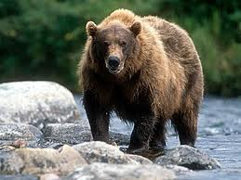
3 Brown bears are found in a few western states and in Alaska. They live in forests as well as in open areas called the tundra. Brown bears are usually light or dark brown and can grow to be very large. In fact, some are eight feet long!

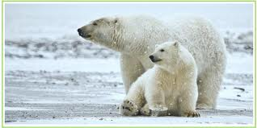
Polar Bears
4 Polar bears can be found in Alaska, which is in a cold region near the North Pole called the Arctic, where there are no trees. Polar bears are white, and they are the largest of the three kinds of bears. They are a little longer and usually heavier than the brown bear.

Other Interesting Things
5 Bears eat different things. Black and brown bears eat fish and other kinds of meat, roots, and berries. Polar bears eat fish, other meat, seaweed, and grass. All three types of bears eat as much food as they can find just before winter.

6 During the cold months they sleep in caves or hollowed out trees called “dens,” which keep them warm. Winter is when the female bears have their babies. All three types of bears have between one and four cubs. The cubs are born while the mother bear sleeps!

7 All people are afraid of bears. However, bears are actually shy. Most bears try to stay away from people, but still, bears can be dangerous at times. Mother bears do not want people to get too close to their babies, and bears do not want people to get close to their food!
6. The author wrote this text mainly to

A. | explain why bears sleep all winter.
B. | describe three kinds of bears.
C. | tell people not to feed bears.
D. | show how dangerous bears are.

7. Why do bears most likely eat as much as they can before winter?

A. | They are only hungry just before winter.
B. | They are too shy to come out during winter.
C. | They can find plenty of food to eat in the winter.
D. | They sleep all winter and need the nutrition.

8. Which paragraph of this text tells the reader the most common type of bear?

A. Paragraph 2: Black Bears
B. Paragraph 3: Brown Bears
C. Paragraph 4: Polar Bears
D. Paragraph 5: Other Interesting Things

9. Which sentence from the text states the author’s opinion?

A. Three kinds of bears live in the United States.
B. Brown bears are found in a few western states and in Alaska.
C. Bears eat different things.
D. All people are afraid of bears.

10. Which detail does NOT support the main idea of paragraph 5?

A. Bears eat as much food as they can find.
B. Black bears eat fish and other meat.
C. Some brown bears are eight feet long.
D. Polar bears eat seaweed, grass, and fish.

Read the text. Then read each question. Choose the best answer.

Day and Night in the Desert

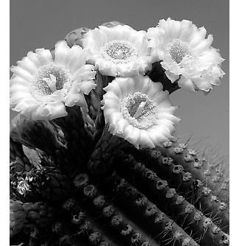
1 In late spring, the desert is very hot and dry. But it is full of life. During the cool night, a beautiful saguaro cactus flower blossoms. In the morning, painted lady butterflies suck nectar from wildflowers growing in the sun.

Saguaro cactus blossoms last only one day in the hot desert sun.

2 Nearby, a hungry lizard watches. It soon snaps up a butterfly and scurries away. Then it rests on a rock warmed by the sun. Lizards have to eat, too.

This western whiptail lizard has long claws to dig for food and catch insects.

3 A young snake slithers by, very quietly. It strikes quickly and gobbles up the lizard. The snake won’t be hungry for the rest of the day.

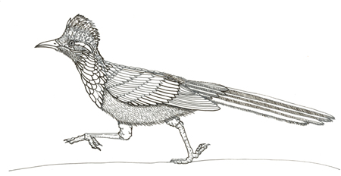
4 Most desert animals stay hidden in the shade during the hot afternoon. But at sunset the desert begins to cool. A roadrunner darts out from behind a barrel cactus. Roadrunners are very quick. The snake is a nice treat.
Roadrunners can’t fly very well, so they run fast instead.

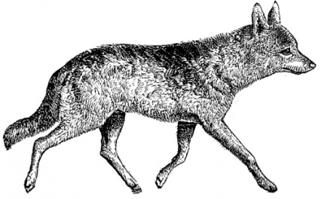

5 In the evening, a coyote waits in the darkness. It has begun its night of hunting to bring food to its family. It doesn’t bother to chase the roadrunner. A roadrunner is very hard to catch. The coyote looks for a kangaroo rat instead.
Coyotes hunt rabbits, rodents, fish, frogs, and even deer.
6 Under the desert moon, another saguaro flower blossoms. In the morning, a butterfly will sip nectar from wildflowers, and the search for food in the desert will begin again.

11. What is the main topic of this text?

A. | Cactus flowers blooming at night
B. | What lizards eat in the desert
C. | The plants and animals that live in the desert
D. | How fast roadrunners can run

12. Most desert animals stay hidden in the afternoon to

A. | sleep
B. | stay cool
C. | eat their prey
D. | hide from enemies

13. According to the text, what will happen tomorrow in the desert?

A. | It will be very different.
B. | The animals will not find food.
C. | The animals will do the same thing again.
D. | The coyote will chase the roadrunner.

14. Why does the coyote hunt for the kangaroo rat instead of the roadrunner?

A. The kangaroo rat is very fast.
B. The roadrunner is too fast to catch.
C. The lizard is hiding behind a cactus.
D. The kangaroo rat is the coyote’s favorite food.

Read the story. Then read each question. Choose the best answer.

Strange Rain

1 Sedat sat on the edge of his bed looking out the window after the thunder woke him up. He wasn’t bothered much because he loved to watch storms. It was so dark and shadowy outside, though, that he could barely see out his window. As the storm continued, he heard an odd, thumping sound followed by what sounded like a bark. Then there was another thumping noise and what sounded like a meow. He decided to reach under his bed for his flashlight.

2 Sedat flipped the switch on the flashlight and pointed it toward the yard. All he could see was the glare from his window. He slipped out of his bed and opened the window and then heard more strange sounds. When he pointed his flashlight into the yard, he could not believe his eyes. It was raining cats and dogs!
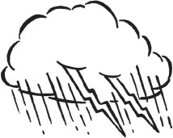
3 Sedat rubbed his eyes and looked again. A cat landed softly on its feet and ran under a bush. A dog landed close by, and the cat jumped out. Then the two animals started to play.
4 Sedat saw his cat, Link, walking through the garden. Other cats and dogs rained down in the yard. Sedat worried that Link would disappear into the night with all of the other animals, so he put on his slippers and hurried down the stairs. He opened the back door and called out to Link and noticed that it was barely raining now. As he peered out at the darkness, he saw a cat moving toward him. He called Link’s name again, and suddenly, Link ran inside and rubbed against Sedat’s legs. Sedat dried Link gently with a towel, carried him upstairs, and fell asleep with his cat curled at the foot of the bed.

5 Sedat woke up early the next morning, and the sun was shining brightly. He dressed quickly and walked downstairs. His mother was opening the back door to go outside, and Sedat went out with her.

6 Sedat’s mom looked at the garden. She propped up a flower pot that had been knocked over. Then she cut off a broken branch on another plant.

7 “Look how many plants were damaged during last night’s storm,” she said. “It must have rained cats and dogs.”

8 “Yes, it did,” Sedat agreed. He smiled as Link rubbed against his legs and purred.
15. Where does this story take place?

A. | Sedat’s house
B. | the park
C. | the woods
D. | a basement

16. What does Sedat do to show he cares for Link?

A. | He watches his cat in the yard.
B. | Sedat watches Link lick his paws.
C. | He looks out his window.
D. | Sedat dries Link with a towel.

17. Which word best describes Sedat?

A. | curious
B. | funny
C. | troubled
D. | fearful

18. Why did Sedat rub his eyes and look out the window again?

A. There was a flash of lightning and crash of thunder.
B. He heard his mom shout to their pet cat.
C. He thought he saw cats and dogs falling from the sky.
D. It was dark, shadowy, and raining outside.

19. Which of the details below takes place last in the story?

A. | Sedat sees a glare from his window.
B. | Sedat and Link fall asleep.
C. | Sedat hears a thumping sound.
D. | Sedat sees it raining cats and dogs.

20. Sedat smiles at the end of the story because -

A. | Link is safe inside the house.
B. | his mother’s garden is unharmed.
C. | his mother goes outside with him.
D. | he knows it really did rain cats and dogs.

