Read the selection. Then read the question. Choose the best answer.

Missing Mark
by Mary Penn
illustrated by Amy Wummer

“Who will take me to get ice cream when you’re gone?” Ashley asked. She watched her big brother, Mark, lay a shirt in his suitcase.

“Maybe Mom. She likes ice cream,” Mark said.
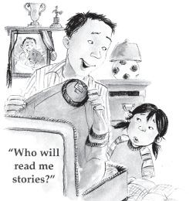
“Who will read me stories?”

“Maybe Grandma. She’s the best story reader in the world.” Mark closed his suitcase.

“Who will draw me pictures?”

“Maybe Dad. He used to draw pictures for me,” Mark said, giving Ashley a big wink. “That’s it! I’m off to college!”

“But I’ll miss you!”
“I’ll come home for visits. You know I’m leaving you in charge while I’m away. Don’t let me down.”

The next Saturday morning, the corners of Ashley’s mouth drooped when she looked into Mark’s empty room. He had been gone for five days, but it seemed like forever. When she slowly plodded down the stairs and into the kitchen, Mom and Dad were talking.

“Maybe we should take Oliver to the vet,” Mom said. Mark’s big beautiful dog, Oliver, was on the floor staring at the kitchen door. “He won’t eat. He just lies there waiting for Mark.”

Dad smiled at Ashley and gave her a hug. Mom poured cereal and milk into a bowl for her.

“You can help us in the garden after you eat, Ashley,” said Mom. “We all miss Mark. If we stay busy, we won’t think about it so much.”

Ashley plopped down next to Oliver as Mom and Dad went outside. The big brown dog didn’t move. His sad, hopeful eyes gazed at the door.

“I miss Mark, too,” said Ashley, scratching his ears. Oliver looked at Ashley and whimpered.

“If you want, I’ll be your new best friend. You can sleep on my bed. I won’t mind at all.”

Ashley jumped up. She got Oliver’s bowl of food and set it in front of him with a clatter. Milk splashed on the floor as she carried her cereal bowl from the table. She settled next to Oliver.
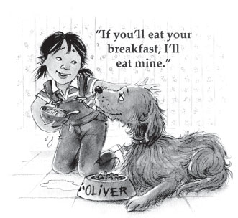
“If you’ll eat your breakfast, I’ll eat mine,” she said. She stuffed a spoonful of cereal in her mouth. Oliver slowly licked up the spilled milk. She put some of her cereal in Oliver’s bowl. She smiled when he began munching his food.

Ashley put her arms around Oliver and felt much better. Being in charge was going to be a full-time job.

- What happens in the beginning of the story?

A. | Ashley gets a dog named Oliver.
B. | Mark finds a full-time job.
C. | Mark goes to college.
- What does the introduction of this story tell you about Mark and Ashley?

A. | They like to spend time together.
B. | They bother each other.
C. | They are leaving together.
- What event happens in the middle of the story?

A. | Ashley asks Mark questions.
B. | Ashley gets a full-time job.
C. | Ashley tells Oliver that she misses Mark.

- At the end of the story, how are Ashley and Oliver alike?

A. | They both start to feel better.
B. | They both eat ice cream.
C. | They both like stories.

- What does the end of the story tell you about Ashley?

A. | Ashley learns she will be busy.
B. | Ashley feels angry Mark left home.
C. | Ashley helps her mom in the garden.

Read the text below. Then read the question. Choose the best answer.

A Star Is Born

Mia Hamm was born in 1972. As a baby, she had problems with one of her feet. Her mom and dad did not know if she would ever walk or run or kick a ball, but she learned to do all of these things. Mia’s parents did not know that she would grow up to be a big star, but she did. She became a soccer star!
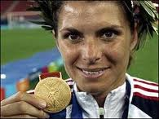
Mia Hamm shows her Gold Medal from the 1999 Women’s World Cup.

Soccer is a game in which two teams play against each other.
Each team has 11 players. The players cannot move the ball with
their hands or arms. Each team tries to score points by kicking
the ball into the goal. The winner is the team that gets the most
points.
Mia started playing soccer when she was only 5 years old.
By the time she was 15, she was such a good player that she
started winning prizes. Mia loved playing the game, and people
liked watching her. After she finished school, she continued to
play. She played soccer games all over the world and helped
her team win many games.

A lot of girls who watched Mia play wanted to be just like her. Mia wanted to show the girls how to have a dream and work for it, so she started teaching them how to play soccer. Now many girls love playing soccer as much as Mia does.

- What is the topic of the text?

A. | winning prizes
B. | soccer star
C. | gold medal
- Why did Mia’s parents think she may never walk or run?

A. | She was very ill.
B. | She had problems with her foot.
C. | She was afraid.
- Mia teaches girls to play soccer because she—

A. | wants to show them how to work for a dream.
B. | needs more soccer players on her team.
C. | thinks that everyone should learn to play soccer.

- What is the focus, or main idea, of the paragraph with the ?

A. | Mia became a soccer star.
B. | Many girls watch Mia.
C. | How to play soccer.

- A soccer team scores a point when a player—

A. | throws the ball into the goal.
B. | catches the ball.
C. | kicks the ball into the goal.

- The reader can tell that “A Star Is Born” is a nonfiction text because it—

A. | gives facts about a real person.
B. | is about a soccer game.
C. | tells about a girl and her parents.

- The author’s purpose for writing this text is to—

A. inform the reader about Mia Hamm’s life.
B. persuade the reader to watch soccer.
C. describe how to play soccer.

- Where would you find the information about Mia’s gold medal?

A. the caption
B. the title of the text
C. the heading

Read the selection. Then read the question. Choose the best answer.

Ben Franklin and His First Kite
written by Stephen Krensky
illustrated by Bert Dodson
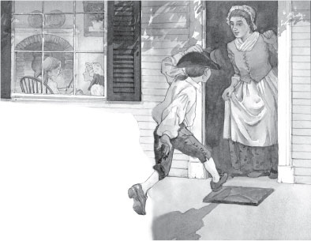
That afternoon Ben flew down the streets of Boston. He was headed for home. Along the way he noticed the waves cresting in the harbor. The ships rocked back and forth. That was good, he thought. He needed a strong wind today. When Ben got to his house, his mother met him at the door. Inside, two of his sisters were busy making pudding by the fireplace. Ben had sixteen brothers and sisters.

“Ben,” his mother said, “why are you in such a hurry?”

Ben told her about his plan.

“Since your father approves, I won’t keep you,” said his mother.

“Just be back for dinner.”

Ben nodded. He ran to get the kite he had made the week before. Then he left the house. At the millpond a few of Ben’s friends had arrived to watch.
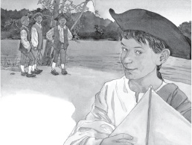
“You’ve picked a poor place to fly a kite,” said one.

Ben shrugged. “I’m doing an experiment,” he said.

Ben got undressed. He gave his clothes to one of his friends.

“Please carry these to the other side of the pond,” he said.

“What are you going to do?” asked the other boys. “Carry the kite while you swim?”

“No,” said Ben. “The kite is going to carry me.”

“But that kite’s nothing special. It’s just paper, sticks, and strings,” said one boy.

“That’s true,” Ben said. “But you see, the kite isn’t the invention. The invention is what I’m going to do with it.”

Ben raised the kite in the air. Once the wind had caught and carried it aloft, Ben walked into the water. There he lay on his back, floating.

“I’m going to cross this pond without swimming a stroke,” said Ben.
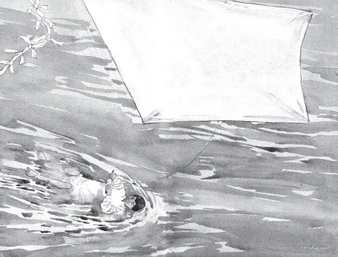
The wind tugged on the kite. The kite string tightened. The water began to ripple at Ben’s feet. The kite was pulling him!

The boys whooped and hollered as Ben glided across the pond. Finally he reached the other side. The other boys met him there.

“That was amazing!” said one.

“You crossed the whole pond without swimming a stroke,” said another.

“What will you do next?” they asked.

“Another invention?”

“A different experiment?”

Ben didn’t know. But he was sure he would think of something.

- Which sentence best describes Ben?

A. He wants to make boats when he grows up.
B. He likes to try new things.
C. He likes making people laugh.

- What happens after Ben gets his kite to fly?

A. The kite falls into the water.
B. Ben takes the kite to the pond.
C. The kite pulls him across the pond.

- Which sentence best tells what this story is about?

A. Ben likes to do many things with his brothers and sisters.
B. Ben learns that candles are more important than kites.
C. Ben finds a way to cross the pond without swimming.

- Why does Ben want a strong wind for his experiment?

A. Ben does not know how to swim and is afraid.
B. Ben wanted to cross the pond without swimming.
C. Ben wants to win the race against the other boys.

- The authors’ purpose for writing this text is to—

A. describe how to build a kite.
B. inform the reader about Ben Franklin’s experiment.
C. answer questions about Ben Franklin’s life.

Writing

Read
Together
What does your body need to stay strong and healthy?
Write a piece that informs or explains what your body needs to stay strong and healthy.
Read
Together
REMEMBER, YOU SHOULD
- Write an introduction to your topic.
- Include at least one important idea about staying strong and healthy.

- Give facts and examples that explain and support your ideas.
- Use and write different types of sentences.
- Use complete sentences.
- Use correct spelling, capitalization, punctuation, and grammar.
- Write a conclusion.

