Read the story. Then read each question. Choose the best answer.

The Potato’s Path

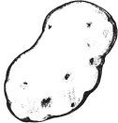
I love to eat potatoes.
Yum, yum, yum, yum, yum!
But when I eat potatoes,
I wonder where they’re from.
Do they drop down from the air
Or wash in from the sea?
My brain keeps asking where,
So Mom sat down and told me.
“Potatoes come from far away,
From a farm out on the plain.
The farmer picks them every day
And puts them on a train.
They ride the train all day and night,
And when the sun comes up,
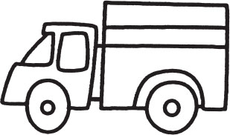
A team of workers use all their might
And load them on a truck.
The spuds are driven through the town
And to the grocer’s door.
The grocer weighs them to the pound
And puts them in the store.”

Potatoes make me happy!
I know just where they’re from.
They’ve made a long, hard journey
To travel to our home.

- Look at these sentences from the poem again.

The spuds are driven through the town
And to the grocer’s door.
The grocer weighs them to the pound
And puts them in the store.

A grocer is someone who ______

A. | sells food.
B. | grows potatoes.
C. | drives a truck.
- Where do potatoes start their journey?

A. | at the store
B. | in a train
C. | on a farm

- What probably happens after the grocer puts the potatoes in the store?

A. | Workers put them on a train.
B. | They get loaded onto another truck.
C. | Someone buys them.

Read the story. Then read each question. Choose the best answer.

Who’s Home in the Prairie Dog Town?
by Catharine Ripley

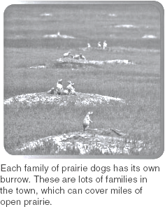
Prairie dogs are busy animals. Prairie dogs use their long, curved claws to dig lots of escape holes, so they will always have safe spots to hide. They also dig large, deep tunnels to live in. At the front door of their homes, they mound up the earth. The small hill makes a great lookout tower! Just inside the tunnel, there is usually a room where a prairie dog can listen for danger but remain hidden. Deeper down is a nesting room for babies and maybe a sleeping room. All the homes have a back door. After all, some predators, such as black-footed ferrets, sneak into the tunnels to hunt prairie dogs. It’s smart to have more than one way out!
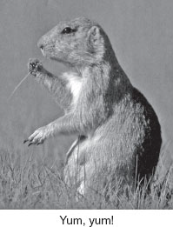
Prairie dog tunnels stay warm in the freezing winter and cool in the hot summer. They help improve the soil on the dry prairie too. All that digging loosens the earth, allowing rain to seep in more deeply.
Prairie dogs don’t just dig and dig. They eat and eat. Their nibbling keeps the tall grasses clipped short. Trimming the grass keeps it fresh and nutritious, and makes room for other kinds of plants to grow. The variety of plants in prairie dog town attracts many different kinds of animals.

Antelope and bison often drop by to munch on the young, tender grass. Sometimes a bison will take a dust bath. It rolls around in the short grass and dirt to rub off the itchy pests on its back. The plants growing in prairie dog town also attract many insects, and the insects in turn attract the birds, mice, and lizards that eat them.

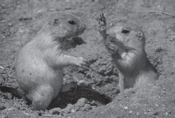
So, prairie dog town is home to lots of animals, not just prairie dogs. Rattlesnakes, burrowing owls, and rabbits even use abandoned prairie dog burrows for their homes.

Without all the nibbling and digging by prairie dogs, the prairie would be much less lively and healthy. And less noisy, too!

- What is the main topic of Who’s Home in the Prairie Dog Town?

  - Prairie dogs and their tunnels
  - Foods that prairie dogs like to eat
  - Prairie dogs and where they live

- Why did the author write this text?

A. | to answer questions about the prairie
B. | to explain how animals dig holes
C. | to describe prairie dogs

- How do prairie dogs use their long, curved claws?

A. | to dig
B. | to scratch
C. | to run

- Why do prairie dogs need lookout towers?

A. | to stay warm
B. | to spot trouble
C. | to dig deep tunnels

- Look at the pictures in the text. How do prairie dogs eat?

A. | They use their claws to grab plants from the water.
B. | They use their hands to bring food to their mouths.
C. | They lie down in the grass to eat.

- Why do bison roll in the short grass?

A. | to kill the short grass
B. | to rub pests off
C. | to trap lizards

- What is the focus of the paragraph with the ?

A. | Antelope live in the prairie.
B. | Prairie dog tunnels have many uses.
C. | Prairie dog town is home to lots of animals.

- What point does the author make in this text?

A. | Prairie dogs are very busy animals.
B. | Prairie dogs make great pets.
C. | Prairie dogs eat lots of different things.

Read the story. Then read each question. Choose the best answer.

Zachary’s Feather

by Virginia S. Baldridge
art by Helen Cogancherry

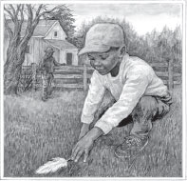
One day when Zachary was visiting his grandpa and grandma, he found something on the grass.

“Look, Grandpa, a bird lost a pretty white feather,” he said.

“Might be from a chicken,” Grandpa said, “because it’s so big. Put it in your cap and you can be Yankee Doodle.”

But Zachary wasn’t listening. He was running back to the kitchen.

“Grandma, Grandma,” he called. “I need a glass of water!”

“Are you thirsty?” asked Grandma, getting a glass from the cupboard.

Zachary dragged the kitchen stool over to the sink and climbed up. “I can do it,” he said. He filled the glass with water.

“It’s not for me,” he told Grandma. He put the feather carefully into the glass of water and climbed down.

That night, after he had taken his bath and Grandma had read three stories to him, Zachary fell asleep. He dreamed that his feather sent down white tangled roots inside the glass, like the ivy his mother grew in water. From the top of the feather grew a beautiful feather vine, curling upward, branching out and stirring in the breeze from the open kitchen window.

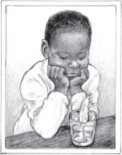
In the morning, Zachary ran downstairs to see his feather vine. But the feather was sticking in the glass of water just as he left it.
After breakfast, Zachary took his feather outside and planted it in the flower garden.
That night he closed his eyes and dreamed of a tall, straight, feather tree, with many branches spreading out to shade the lawn, each branch covered with fluffy feather leaves, shining in the sunlight and swaying in the breeze.

After two days the feather was still the same, only dirtier. Zachary washed and dried the feather. “I want to use my feather for something,” he said fiercely.

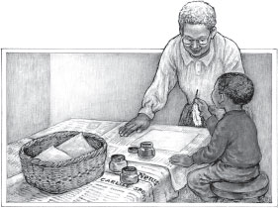
“You could stick it in your baseball cap,” Grandma said. Zachary shook his head. All morning, Zachary carried his feather around, thinking and thinking.

When he got up from his nap that afternoon, it was raining. “How would you like to paint some pictures?” Grandma asked, spreading newspapers over the kitchen table and getting some small jars of red, blue, and yellow paint.

“Oh, Grandma, oh, Grandma! Not a picture, no, not a picture!” Zachary exclaimed. “But I know how to use my feather!”

So Zachary sat at the table and, with some help from his grandma, he used his feather. He dipped it into the red paint and made a letter for his parents.

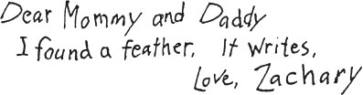

- At the beginning of the story, why doesn’t Zachary listen to Grandpa?

A. | Zachary is too excited.
B. | Grandpa is being silly.
C. | Zachary is busy writing a letter.
- What happens in Zachary’s first dream?

A. | Zachary plants the feather in the garden.
B. | The feather becomes a vine.
C. | Zachary puts the feather in a glass of water.

- The story takes place ______

A. | at Zachary’s grandparents’ house.
B. | at Zachary’s friend’s house.
C. | in Zachary’s dream.

- Why did Zachary’s feather get dirty?

A. | He planted it in the garden.
B. | He put it in his hat.
C. | He put it in a glass of water.

- In this story, why did Zachary think the feather would grow roots in a glass of water?

A. | He thought the feather was thirsty.
B. | He read about it in a story with Grandma.
C. | He saw his mom grow ivy in water.

- Who is telling this story?

A. | narrator
B. | Zachary
C. | Grandma
- How did Grandpa know that the feather might be from a chicken?

A. | The feather is so big.
B. | The feather came from a nest.
C. | The feather was white.
- What did Zachary finally do with the feather at the end of the story?

A. | He put the feather in his cap.
B. | He colored with the feather.
C. | He wrote a letter with the feather.

- What lesson did Zachary learn in the story?

A. | Feathers are very dirty.
B. | Always listen to your grandpa.
C. | Being creative can be fun.

Writing
Read
Together

What is the best season of the year? Is it fall, winter, spring, or summer?

Write an opinion paragraph to tell which season you like best. State your opinion clearly in a topic sentence. Then give reasons. Make sure each reason tells more about your opinion.

Read
Together
REMEMBER, YOU SHOULD
- Write a topic sentence.
- Give reasons that explain why the season you picked is the best.
- Use because and also to link your writing.
- Use and write different types of sentences.
- Write a concluding sentence.
- Use complete sentences.
- Use correct spelling, capitalization, punctuation, and grammar.

