Name _________________________________
Phonics
1. a. back b. batch c. bash d. bath
2. a. cast b. catch c. cash d. cake
3. a. tab b. top c. tub d. tip
4. a. whine b. whale c. whip d. white
5. a. shake b. shine c. shop d. shape
6. a. spring b. scratch c. splash d. stretch
7. a. drop b. drip c. drag d. drum
8. a. wit b. wet c. win d. wed

Comprehension
Questions for What Lives in a Pond?
- Which sentence tells the main topic of the text?
  - Fish and frogs swim into the grass.
  - Plants and animals both live in a pond.
  - The back legs help the frog swim in the water

- How are fish and frogs alike?
- They both live in a pond.
- They both have fins that flap.
- They both have four legs.

- What helps a fish swim?
  - legs and fins
  - fins and scales
  - scales and legs

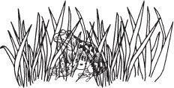
- Which caption best tells about the picture?
  - what fish look like
  - how the frog hides
  - when the frog hops

Questions for Jill’s New Cat
- Why does Jill feel glad at the beginning of the story?
  - She will get a cat.
  - She will run with Dad.
  - She will play with animals.

- Where did Jill and Dad go?
  - to the park
  - to the pet shop
  - to the zoo

- What makes Jill pick up the cat?
  - A cat bumps her leg.
  - A little cat runs past her.
  - She goes to a place that has animals.

- Why does Jill name the cat Puff?
  - The cat likes to play with puffs.
  - The cat puffs when it runs.
  - The cat is white and soft.

- What happens right after Jill says, “I will call her Puff”?
  - Dad nods.
  - The cat naps.
  - Jill picks up the cat.

- Which answer retells the story using KEY DETAILS?
  - Jill and Dad went to the zoo. Jill saw a snake.
  - Jill and Dad went to the pet shop. She got a cat named Puff.
  - Jill was glad. She got a cat.
Writing

Choose an animal to inform your reader about.
Read
Together

Read
Together
REMEMBER, YOU SHOULD
begin with a sentence that tells my reader what animal I am writing about
write 2-3 facts about my animal
have a conclusion that lets my reader know I am finished
use the sounds in the words to help you write them
begin each sentence with a capital letter
use punctuation at the end of each sentence

- Rubric Score: _______

- Rubric Score: ___________

What Lives in a Pond?

A pond is a place filled with water. Plants and animals both live in a pond.
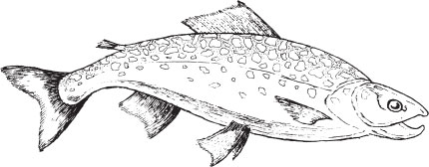

A fish is an animal. It has fins that flap. It has skin made of scales. The scales are flat. The fins and scales help the fish swim.

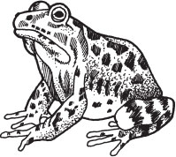

A frog is an animal. It can live in water. It can live on the land, too. It has four legs. The two back legs are long. The back legs help the frog swim in water. They help the frog hop on land.

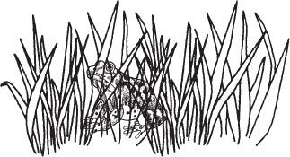

Grass is a plant. It grows in the mud of the pond. Fish and frogs swim into the grass. The grass helps them hide. Big animals can not see them. Then the big animals can not eat the fish and frogs.

Jill’s New Cat

Jill felt glad. She would get a cat.

Dad and Jill went to a pet shop. The pet shop had lots of animals. Jill and Dad went to see the cats.

A big white cat bumped Jill’s leg. It had two blue eyes. Jill bent down and picked it up. The cat was soft.

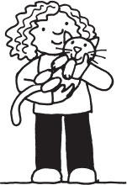

“This is my cat,” Jill said. “She will be a good friend for me.”

“Do you see the little cat?” asked Dad. “A little cat will run and play with you.”

“No, I picked the best cat,” said Jill. “I will call her Puff.”

Dad looked at the smile on Jill’s face. He nodded. Puff would have a good place to live.

