Name _________________________________
Phonics
1. a. steps b. stops c. steep d. stems
2. a. nail b. need c. Ned d. nest
3. a. there b. this c. that d. thank
4. a. smell b. smooth c. smith d. smock
5. a. sail b. seal c. silo d. soil
6. a. farm b. firm c. form d. fern
7. a. pint b. pant c. point d. paint
8. a. face b. fuss c. fast d. fact
9. a. log b. long c. lost d. lion
Comprehension — Questions for Ants
- What does the title tell you about this text?
  - It will tell about ants.
  - It will tell about queens.
  - It will tell about a family.

- What is the main job of the queen?
  - look for food
  - clean the nest
  - lay eggs

- How are queen ants and other ants the same?
  - They all lay eggs.
  - They all work together.
  - They all feed baby ants.

- Which sentence tells the main idea of this text?
  - Only the queen ant lays eggs.
  - Ants have jobs that help their family.
  - Some ants look for food to bring to the nest.

- Why did the author write this text?
  - to tell a funny story
  - to get kids to work hard like ants
  - to tell facts about ants

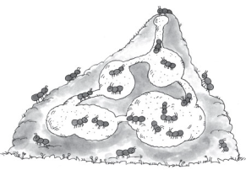
- Which caption would best tell about the ants in the nest?
  - Ants like to fight.
  - Ants live and work together.
  - All ants lay eggs.
Questions for What a Kite!
- What is Joy’s problem in the story?
  - She does not have a kite.
  - She does not have a lunch.
  - She wants to run with Jake.

- What happens AFTER Carl gets some yarn?
  - the family eats lunch
  - Carl gets the lunch bag
  - Joy watches boys and girls fly kites

- Read this sentence from the story.
Carl tied the yarn to the open end of the bag.

What was Carl trying to make?
  - a trash bag
  - a kite
  - a yo-yo

- What happens AFTER Carl gives Joy the bag with the yarn?
  - Joy blows on the bag.
  - Joy puts it in the car.
  - Joy runs with the bag.

- Which word tells how Joy feels at the end of the story?
  - glad
  - mad
  - sad
Writing
Read
Together

Write about something interesting that has happened to you.

Read
Together
REMEMBER, YOU SHOULD
write about something interesting that has happened.
have a beginning, middle, and end.
have at least 2 details.
use signal words, such as next, later, and then.
use the sounds in the words to help you write them.
begin each sentence with a capital letter.
use punctuation at the end of each sentence.
have a conclusion that lets the reader know your story is finished.

- Rubric Score: ___________

Ants

Ants live in many places. They are very small. Ants live in a big family. An ant family lives in a nest. Ant nests can be in the ground or on top of the ground. Some ants make nests in trees.

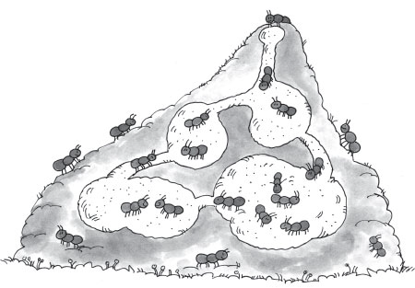

Ants have jobs to do. Each ant does one job, but the ants work together like a team. One ant is the queen. Just one queen lives in a nest. The queen lays eggs. That is her main job.

Some ants clean the nest. Some ants look for food, like seeds. They bring the food back to the nest. One group of ants feeds baby ants. All the ants work hard. It helps the family grow.

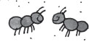

What a Kite!

The Smith family went to the park. They took a lunch. While eating, Carl and Joy watched some girls and boys fly kites.
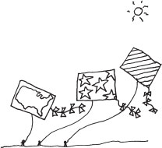

“I wish we had a kite,” said Joy. “It would be fun to fly it.”

“We’ll come to the park again,” said Joy’s mother. “Then we will bring a kite.”

“Wait!” said Carl. “I know what we can do.”

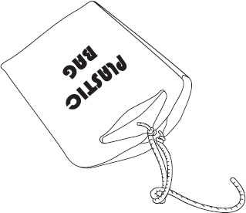
Carl ran to the car. He got some yarn that was in his mother’s bag. Then he got their lunch bag. Carl tied the yarn to the open end of the bag.

“Here, Joy,” Carl said. “Run with the yarn to make the bag fly.” In no time, Joy had the kite flying.

Joy said, “It may not be a real kite, but it is still fun.”

And it was.

